# Ex2

Froe out the exercise we would use the protocol: UDP in the version of IPv4.

The protocol is taken in the format presented at Wikipedia[1] for the above protocol:

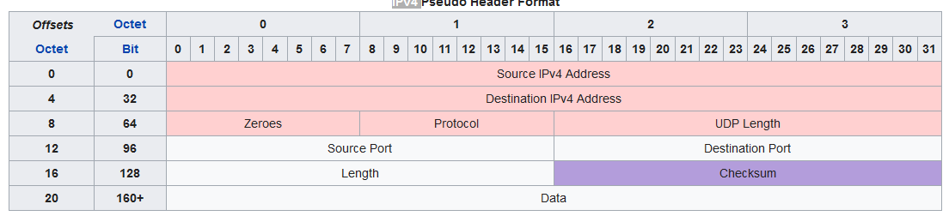

1. <https://en.wikipedia.org/wiki/User_Datagram_Protocol>